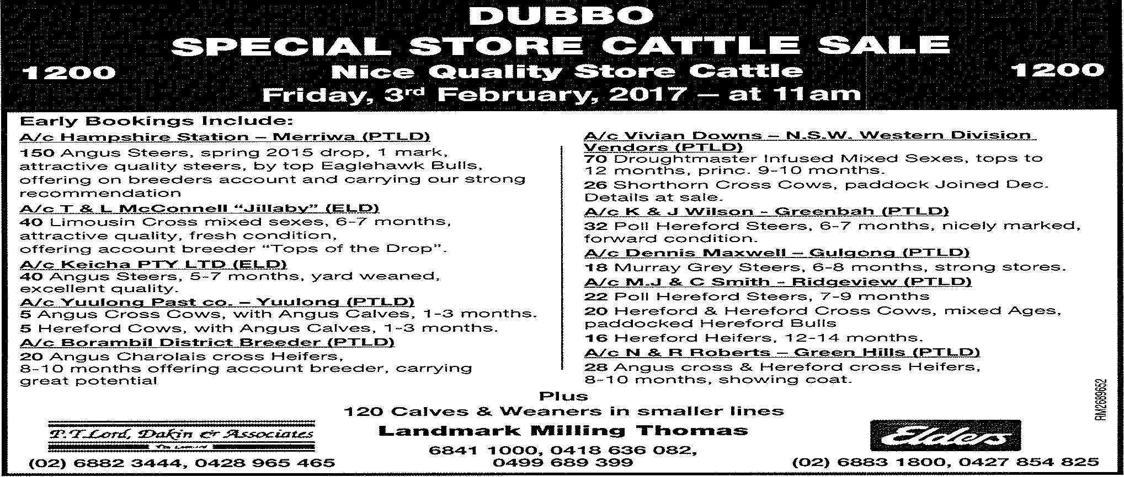
Late Entries
A/c Landmark Milling Thomas company clients (LMT)
20 Angus cows and calves, cows 7-8 yrs, calves 3 months by Angus bulls.
15 Hereford cows and calves, cows mixed ages, calves 2-3 months by Angus bulls.
10 Murray grey cows and calves, 5-6 yrs, calves 4-5 months by Charolais bull, PTIC back to Charolais bulls (blue tag).
A/c Worrell Family (PTLD)
18 Limousin Shorthorn Cross Cows, 7-8 years, 100% calves, up to 4 months, by Shorthorn & Limousin Bulls, re-paddocked same sires
10 Limousin Shorthorn Cross Cows, with Calves, 1-3 months
16 Euro cross mixed sexes
A/c J.T. Rosewood (PTLD)
23 Santa Gertrudis Steers, 13-14 months, attractive quality, offering account breeder
A/c Keith Williams – Moorebank (PTLD)
50 Droughtmaster infused Steers, 9-11 months, fresh condition
40 Droughtmaster infused Heifers, 10-11 months, 1 brand, nice quality
A/c Longview – Come-by-Chance (PTLD)
15 Charolais cross Cows, mixed ages, with Calves, good units
10 Charolais cross Heifers, in good order
15 Charolais cross Steers
A/c W & J Caslick (PTLD)
10 Charolais Heifers
6 Charolais Angus Cross Steers
A/c Wilbertree (PTLD)
10 Droughtmaster Cross Steers, 10-11 months
16 Angus cross Cows, 4-7 years, PTIC

